Part 1: Scientific Notation
What is it?
- In each section, underline items that describe WHY we use scientific notation.
- Highlight all of the rules.
- Change your text to RED as you answer the questions.
Astronomers deal with quantities ranging from the truly microcosmic to the macrocosmic. It is very inconvenient to always have to write out the age of the universe as 15,000,000,000 years or the distance to the Sun as 149,600,000,000 meters. To save effort, powers-of-ten notation is used. For example, 10 = 10¹; the exponent tells you how many times to multiply by 10. As another example, 10⁻² = 1/100; in this case the exponent is negative, so it tells you how many times to divide by 10. The only trick is to remember that 10⁰ = 1. Using powers-of-ten notation, the age of the universe is 1.5 x 10¹⁰ years and the distance to the Sun is 1.496 x 10¹¹ meters.
- The general form of a number in scientific notation is a x 10^{n}, where a must be between 1 and 10, and n must be an integer. (Thus, for example, these are not in scientific notation: 34 x 10⁵; 4.8 x 10^{0.5}.).
- If the number is between 1 and 10, so that it would be multiplied by 10⁰ (=1), then it is not necessary to write the power of 10. For example, the number 4.56 already is in scientific notation (it is not necessary to write it as 4.56 x 10⁰, but you may write it this way if you wish).
- If the number is a power of 10, then it is not necessary to write that it is multiplied by 1. For example, the number 100 can be written in scientific notation either as 10² or as 1 x 10². (Note, however, that the latter form should be used when entering numbers on a calculator.)
The use of scientific notation has several advantages, even for use outside of the sciences:
- Scientific notation makes the expression of very large or very small numbers much simpler. For example, it is easier to express the U.S. federal debt as $3 x 10¹² rather than as $3,000,000,000,000.
- Because it is so easy to multiply powers of ten in your head (by adding the exponents), scientific notation makes it easy to do "in your head" estimates of answers.
- Use of scientific notation makes it easier to keep track of significant figures; that is, does your answer really need all of those digits that pop up on your calculator?
Converting from "Normal" to Scientific Notation
Place the decimal point after the first non-zero digit, and count the number of places the decimal point has moved. If the decimal place has moved to the left then multiply by a positive power of 10; to the right will result in a negative power of 10.
- Example: To write 3040 in scientific notation we must move the decimal point 3 places to the left, so it becomes 3.04 x 10³.
- Example: To write 0.00012 in scientific notation we must move the decimal point 4 places to the right: 1.2 x 10⁻⁴.
Converting from Scientific Notation to "Normal"
If the power of 10 is positive, then move the decimal point to the right; if it is negative, then move it to the left.
- Example: Convert 4.01 x 10². We move the decimal point two places to the right making 401.
- Example: Convert 5.7 x 10⁻³. We move the decimal point three places to the left making 0.0057.
Working with Scientific Notation:
Addition and Subtraction
When adding or subtracting numbers in scientific notation, their powers of 10 must be equal. If the powers are not equal, then you must first convert the numbers so that they all have the same power of 10.
- Example: (6.7 x 10⁹) + (4.2 x 10⁹) = (6.7 + 4.2) x 10⁹ = 10.9 x 10⁹ = 1.09 x 10¹⁰. (Note that the last step is necessary in order to put the answer in scientific notation.)
- Example: (4 x 10⁸) - (3 x 10⁶) = (4 x 10⁸) - (0.03 x 10⁸) = (4 - 0.03) x 10⁸ = 3.97 x 10⁸.

Multiplication and Division
It is very easy to multiply or divide just by rearranging so that the powers of 10 are multiplied together.
Multiplication means add exponents
  - 10⁶ x 10²=10⁸ (exponents: 6+2=8)
  - 10⁶ x 10⁻² = 10⁴ (exponents: 6 = (-2) = 4
Division means subtract exponents.
- 10⁶ / 10² = 10⁴ (exponents: 6-2=4)
- 10⁶ / 10⁻²=10⁸ (exponents: 6- (-2) = 8)
Example: (6 x 10²) x (4 x 10⁻⁵) = (6 x 4) x (10² x 10⁻⁵) = 24 x 10²⁻⁵ = 24 x 10⁻³ = 2.4 x 10⁻². (Note that the last step is necessary in order to put the answer in scientific notation.)
Questions:
- In the following number, circle the coefficient and square the exponent: 3 x 10⁶
Or, indicate the coefficient________3_______and exponent_____6________
- Identify what is wrong with this number: 13 x 10 ¹⁷
1.3 x 10¹⁸ the figure should be between 1 to 9 not past this range.
- Summarize the rules for multiplication/addition:
In case of multiplication the coefficients remain the same but the exponents are added up of the coefficients.
- Summarize the rules for subtraction/division:
When coefficients are divided they remain the same but the exponents are subtracted to give credible digits.
- What would a negative exponent mean?
The number should be divided with the exponent this means the coefficient is a decimal number.

- Which direction does the decimal move in order to convert a negative number?
We move to the left depending on the exponent given.

Part 1.1 Scientific Notation Practice
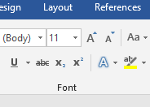
Convert each number to scientific notation. Be sure to check the rules! You will need to use digital tools in order to use the superscript function.

Using superscripts:
In google docs: format→ text→ superscript
In Word: Use the icons in the tool ribbon
- length of a light year: 31,560,00.00 Seconds
3.156 x 10⁶
- Speed of light: 299,794.2 km/sec
2.99742 x 10⁵
- Mass of the Sun 1,989,000,000,000,000,000,000,000,000,000,000 grams
1.989 x 10³³
- Mass of Earth 5,974,000,000,000,000,000,000,000 kg
5.974 x 10²⁴
- One light year 9.46 x 10¹² 9,460,500,000,000 km

- Power output of the sun: 3.827 x 10²⁶ 382,700,000,000,000,000,000,000,000 watts

- Mass of an electron 0.91096 x 10⁻³⁹ 0.0000000000000000000000000000000000091096 kg

- Energy equivalent of one electron-Volt: 0.0000000000000016022 joules
0.16022 x 10⁻¹⁴
- Ratio of proton to electron mass: 1,836.2
1.8362 x 10³
- Planck’s constant 0.0000000000000000000000000000000006626068 ergs/second
0.6626068 x 10⁻⁴²
- Radius of hydrogen atom: 0.0000000000529177 cm
0.529177 x 10⁻¹⁵
- Radius of Earth’s orbit 14,959,789,200,000 cm
1.4959 x 10¹³
- Smallest unit of physical space 0.00000000000000000000000000000000000000016 cm
1.6 x 10⁻⁴⁰
- Diameter of visible universe: 26,000,000,000,000,000,000,000,000,000 cm
Answer here
Answer here
Answer here
Answer here
Answer here
Answer here

2.6 x 10²⁸

Part 2: Introduction to Observing with Stellarium

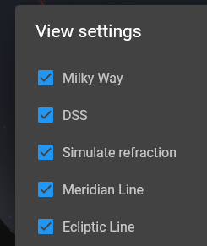
- Open the web browser to get to stellarium. Allow access to your location.
https://stellarium-web.org/
- Create a free account.
- Note this is in REAL time as you are observing!
- Select the options on the right in your settings:
- Watch the tutorial here. This is a bit dry, but necessary info.
- Be sure the location at the bottom left is your location.
- Set your time and date by clicking on the image at the bottom right:


After you have created an account, answer the following questions.

Part 2: Questions

- Where is the general location of the Moon?
The moon is located on the North West in the sky.

- Where is the general location of the sun?
The sun is on the north east in the sky when checked from the compass.

- List and describe 3 viewable objects. Descriptions could be of the objects themselves, their locations, or their relationships to other objects in the sky.
Planets, stars and Arcturus.
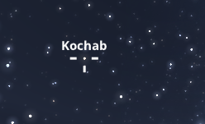
Dragging the crosshairs of your cursor over any object and clicking will display information.

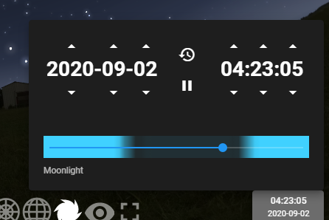
scrollbar
Select time
- Select the scrollbar by clicking the clock in the bottom right.
Move the scrollbar all the way to the left, and observe the changes within the “celestial sphere” as you move it to the right.” Describe 3 things you notice:
I notice that…
- Change in position of the sun

- The moon also shifts to north east
- Position of Arcturus changes slightly
How much time was represented by this? 2 hours 13 minutes.

- Describe how the sky appeared to change as you moved your scrollbar.
The visible objects change their positions opposite directly to their positions they were before the scroll bar was moved, the sun, moon and stars change rapidly.

